We note that we were not able to enrich (both with DO and GO enrichments) all clusters, as in some cases no significant enrichment terms were found, consequently results and plots refer only to the clusters that were successfully enriched.

Going over the barplots generated for all experiments and the available WGCNA clusters uncovers that in all experiments, at least one cluster (and usually not more than two) of genes is tightly connected to neurological functionality, e.g. brain cells development (oligodendrocyte, dendrites etc.), signaling and neurotransmission. Furthermore, we can use the emmaplots and uncover connections between different functions which are inter-connected in some biological pathway. Considering these plots raises questions regarding connections between functions found in the same cluster that are not connected in the graph. These questions should lead to research regarding pathways connecting functions that seem to be associated, at least from an enriched gene-term co expression point of view.

This is an interesting result as it indicates that clustering using WGCNA produces clusters of genes with common functions and not only similar expression levels. This also indicates that in the scenario of neuropsychiatric disorders, a group of genes with similar expression levels might be responsible for the pathogenesis, meaning up/down regulation of this group is the reason behind the disease development.

Further investigation of the enrichment results discovers that in case of two clusters whose most enriched terms are connected to neurological functions, one cluster seems to be more connected to signal processing and transmission (synapses functions, signal release, neurotransmitters) and the other seems to be connected to brain cell development (oligodendrocyte differentiation, glial cell development). This result and its credibility will be further discussed in the discussion section.

**DO**

First, we were much less able to successfully enrich clusters using DO enrichment, therefore we received considerably less results with a serious concern for their quality. We hypothesized that results would indicate connections of at least one cluster of genes (at each experiment) to some neuropsychiatric disorder. Meanwhile, results indicate connection to such disorders in only four[1] out of the 9 experiments with low specificity as the results also connected to neurodegenerative diseases and other neurological disorders. As this results add to those of the GO enrichment, we suspect that the GO results are not as impressive as we first thought, as they are not specific to SZ and BD and rather indicate that some neurological process was compromised (which could lead to various disorders as is seen in the DO results).

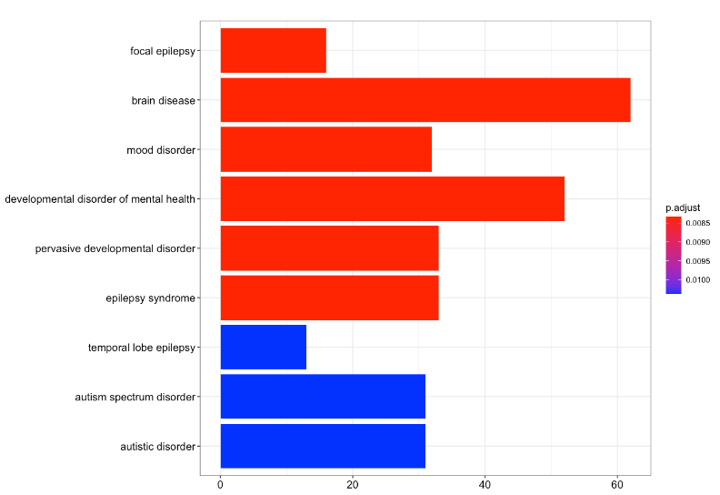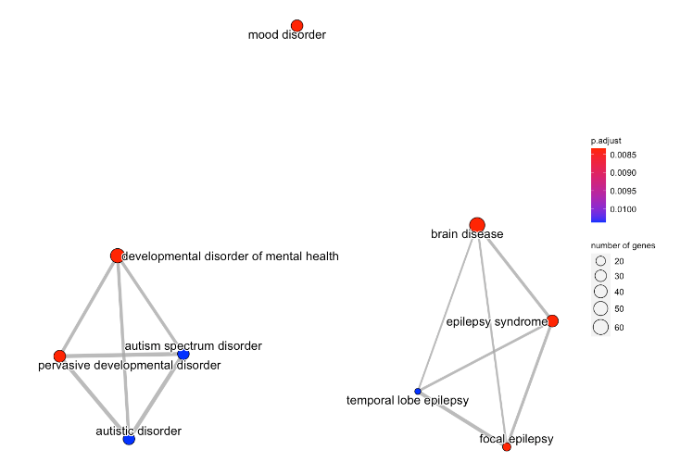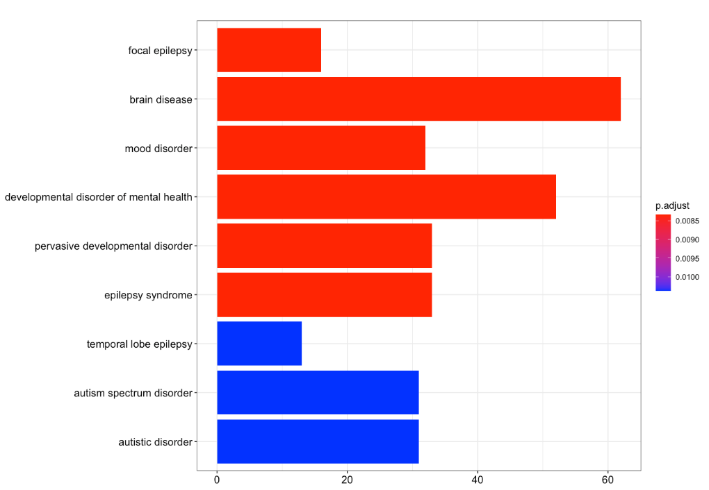

Figure : DO Enrichment for Scizophrenia (SZ) in BA24, Left: barplot of the 20 (9) most enriched terms, Right: emmaplot indicating between-term interadctions and possible connections between disorders. We can see that the connection to neurological disorders exists while not being specific to SZ or any neuropsychiatric disorder for that matter. The emmaplot reveals connections between the different terms, seperating them to clusters, further highlighting the lack of specificity revealed in this analysis.

1. Disease (Both SZ and BD, without specification) in BA9, Bipolar Disorder in BA11, Disease in BA11, Schizophrenia in BA24.